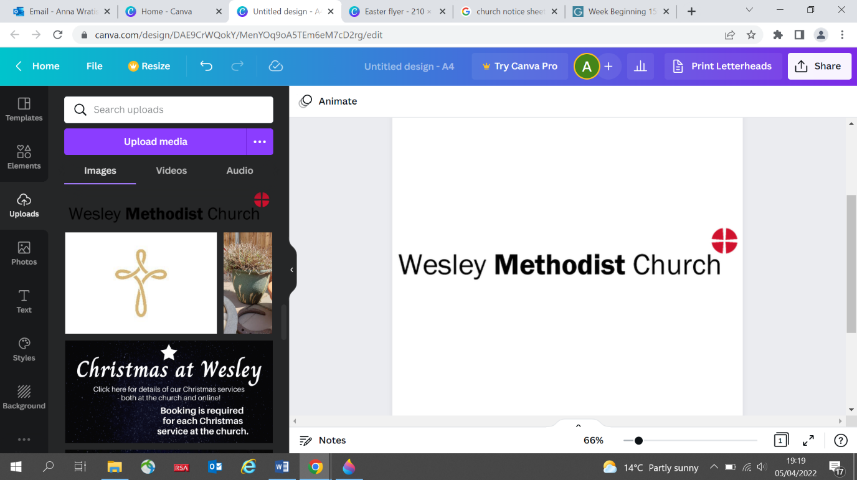

# **Elm Road, Leigh-on-Sea**

**Notice Sheet**

**Welcome to**

**Sunday 25th September L2022**

**Wesley Methodist Church**

Lectionary Readings today: Amos 6 v1a and 4-7; Psalm 146; 1 Timothy 2 v1-7 and Luke 16 v1-13

*The mission of Wesley Church is to proclaim the love of God revealed in Jesus Christ and to help people in their search for God*

**Follow us on:**

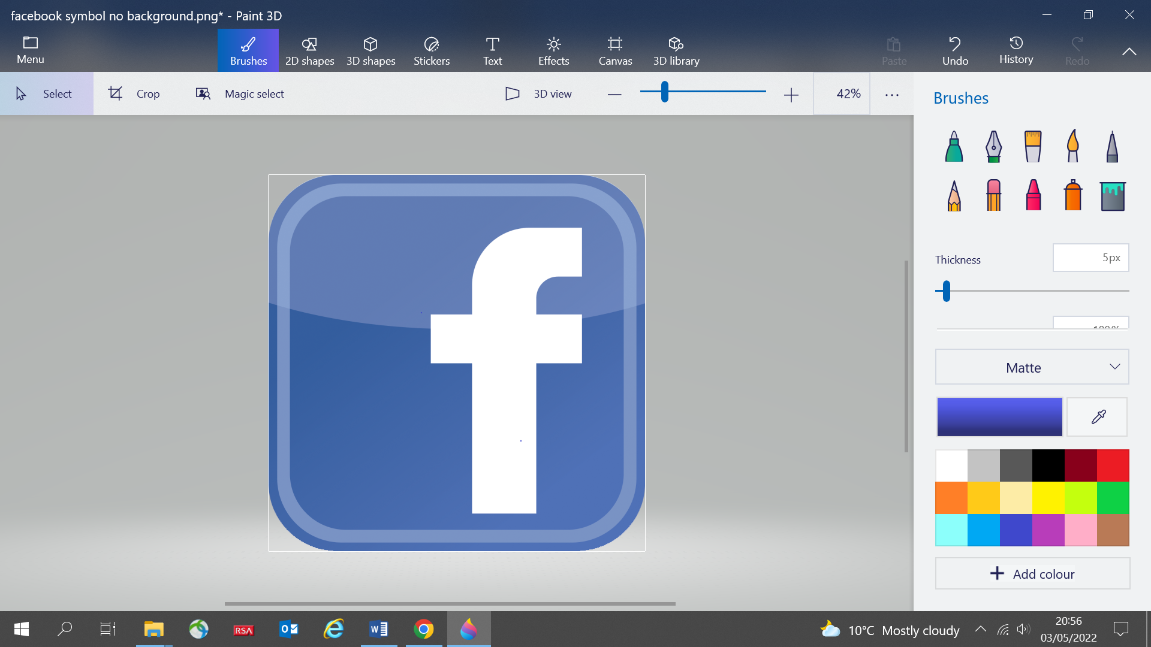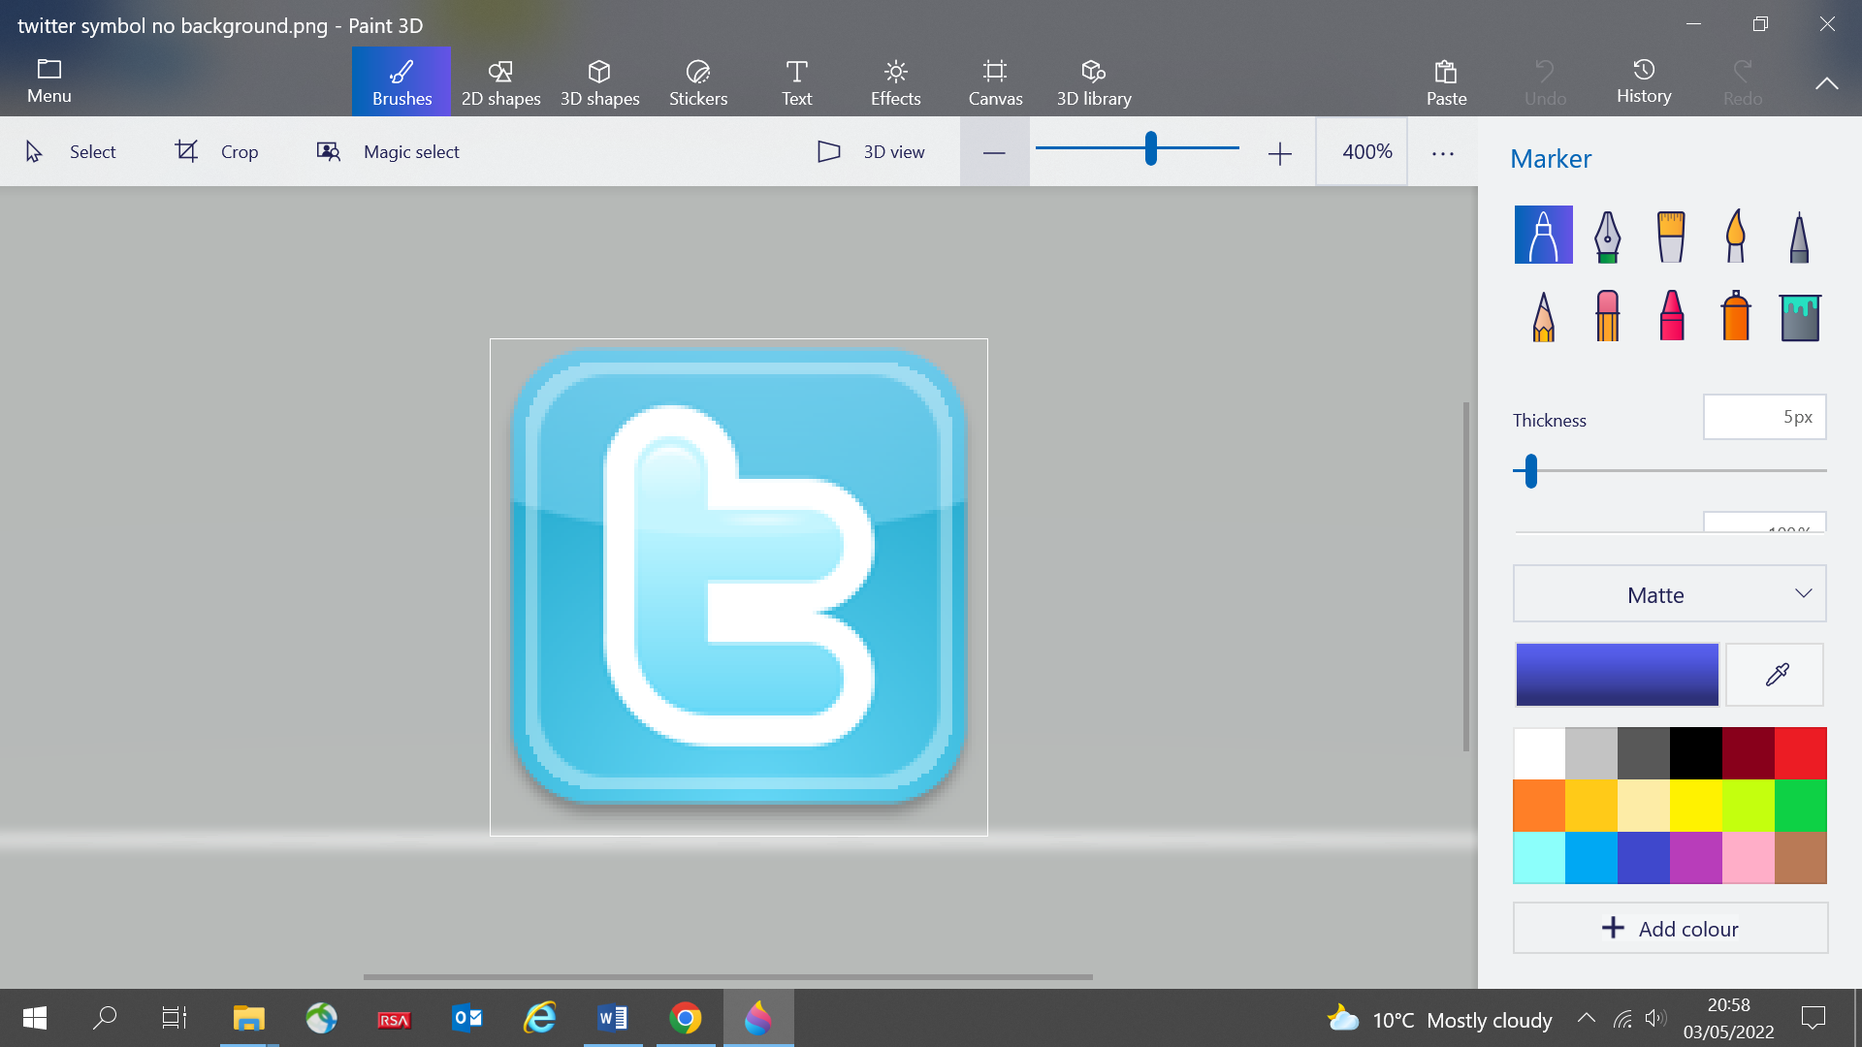

**Find us on:**

**Elm Road**

**Leigh-on-Sea**

**Essex**

**SS9 1SJ**

**www.wesleymethodist.org.uk**

**Notices**

**WORSHIP WEEK BEGINNING 26TH SEPTEMBER**

**All Age Worship includes Communion**

Sunday 2nd October 2022 at 11 am

Rev P Perowne

Lectionary readings: Habakkuk 1 v1-4; 2 v1-4; Ps 37 v1-9

2 Timothy 1 v1-4 and Luke 17 v5-10

**Creative Worship**

**Tuesday 27th September at 8 pm**

**Do you have an item for the notice sheet? Please email notices@wesleymethodist.org.uk or speak to Sue Hockett**

**Contact us:**

Pastor Steve Mayo - Minister

01702 483827

pastorstevemayo@gmail.com

Church Office

01702 711851

General Enquiries

info@wesleymethodist.org.uk

Lettings

lettings@wesleymethodist.org.uk

**MACMILLAN COFFEE MORNING**

**SATURDAY 1ST OCTOBER**

**CAKE DONATIONS GRATEFULLY RECEIVED**

**CONTACT EMMA 07766588877**

[**emmahearnwesleychurch@btinternet.com**](mailto:emmahearnwesleychurch@btinternet.com)

**ALL YOUR SUPPORT IS APPRECIATED**

**The Sanctuary Café**

Fridays 10am-12 noon

Saturdays 10am-1pm

Tea | Coffee | Homemade Cakes

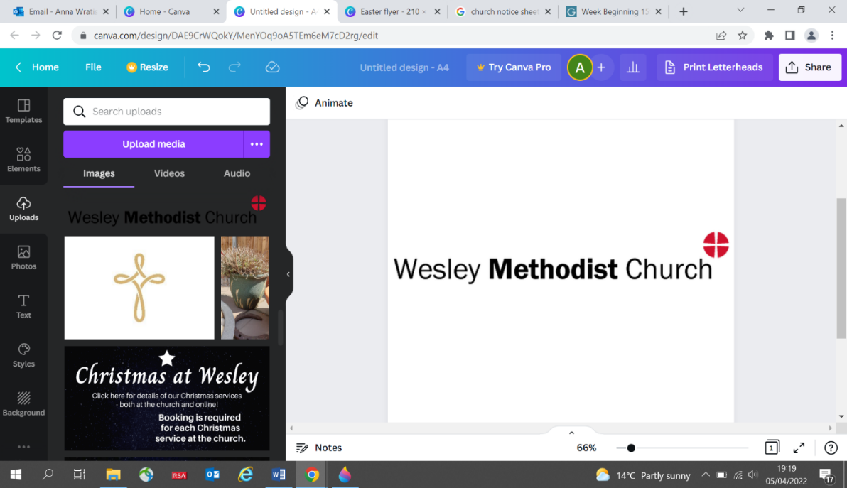

**HARVEST FESTIVAL SUNDAY 9TH OCTOBER**

**A CAFÉ WORSHIP LED BY JANE FULFORD**

**DONATIONS PLEASE FOR THE FOOD BANK DETAILS BELOW**

***We are inviting the pre-school, mother and toddler and cradle roll families to attend.***

Items needed: tinned carrots, potatoes, sweetcorn, tomatoes, jam, long life fruit juice and milk, hotdogs, tinned chicken in sauce, chilli curry meatballs, rice, biscuits, custard, tinned fruit – strong carrier bags.

**CRAFT FAIR SATURDAY 29TH OCTOBER 10-3PM**

EVERYONE WELCOME – LUNCH AVAILABLE

INFORMATION AND TABLE BOOKING CONTACT

JANE FULFORD 01702 714213

**CIRCUIT PRAYER DAY – REFRESH/RECHARGE**

Rayleigh Methodist Church 10-2pm 29th October

Soup lunch provided

**CHRISTMAS GIFTS FOR CHILDREN AND YOUNG PEOPLE**

*We are all aware of the rise in the cost of living and that many families are struggling financially now. We will be supporting local charities and want to encourage everyone to give generously this year. Details of our Christmas Gift Service will be announced in the next few weeks.*

**Notice 7**

Who/what/when/where/why…………..

**Welcome to**

**Wesley Methodist Church**

*The mission of Wesley Church is to proclaim the love of God revealed in Jesus Christ and to help people in their search for God*

**Find us on:**

**Elm Road**

**Leigh-on-Sea**

**Essex**

**SS9 1SJ**

**www.wesleymethodist.org.uk**

**Follow us on:**



**Contact us:**

Pastor Steve Mayo - Minister

01702 483827

pastorstevemayo@gmail.com

Church Office

01702 711851

General Enquiries

info@wesleymethodist.org.uk

Lettings

lettings@wesleymethodist.org.uk

**The Sanctuary Café**

Fridays 10.00 am-12 noon

Saturdays 10am-1pm

Tea | Coffee | Homemade Cakes